Theatre Xavier Macbeth Website Ideas

Purpose Ideas
- Theatre Xavier Informational Page (What Is TX)?
- About TX (highway sign) blurb underneath
- Webpage like a highway junkyard as the imagery
- Intermission (push website during it as a Macbeth regime propaganda site).
- Merch/Macbeth propaganda.

Audience
- People who have NO idea what TX is.

Visual Ideas


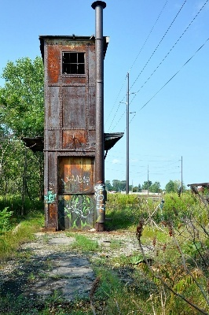






Examples for TX Recruiting
- About TX
- Things YOU Can Do If you Join TX
- What is your favorite things about TX
- Interview Current Tx’ers

